**STADA HEALTH REPORT 2020: Digital Press Conference**

17 June 2020, 10.00 to 11.30 am (CEST)

via Zoom

**Where can I find technical support?**

If you have any questions regarding the Zoom software or the course of the press conference, please do not hesitate to contact the agency komm.passion: [Larissa.Borgmann@komm-passion.de](mailto:Larissa.Borgmann@komm-passion.de)

The explanatory video (1:45 min) shows you how to join a Zoom meeting, whether by phone or computer, and how to select and set up your speakers:

<https://www.youtube.com/watch?v=hIkCmbvAHQQ>

**How does the digital press conference proceed?**

The speakers will give live presentations, the corresponding slides and sound will be broadcast via Zoom. Peter Goldschmidt, CEO STADA, Dr Shari Langemak, physician and e-health specialist, Tim Irfan, Associate Director KANTAR, and Frank Staud, Executive Vice President Global Communications, Branding & Sponsoring STADA and host of the event, will be on the podium. It is possible to ask questions during the event via the Q&A-symbol. These will then be answered by the experts.

**Which technical requirements must be met?**

You can dial in with a Windows computer, Mac, iPad, iPhone, or Android device by following the instructions of the webinar registration you received by email. If you are using Zoom for the first time, the Zoom web browser client will automatically be downloaded when you open or participate in your first Zoom meeting. Alternatively, a manual download is also available:

<https://zoom.us/download#room_client>

You can access the web conference online via all major internet browsers (e. g. Firefox, Google Chrome, Internet Explorer, Safari). **Please dial in 10 minutes before the beginning of the conference to set all technical requirements correctly.**

**How do I participate in the digital press conference?**

1. **Please register via the link in your invitation email.**

**Step 1:**

****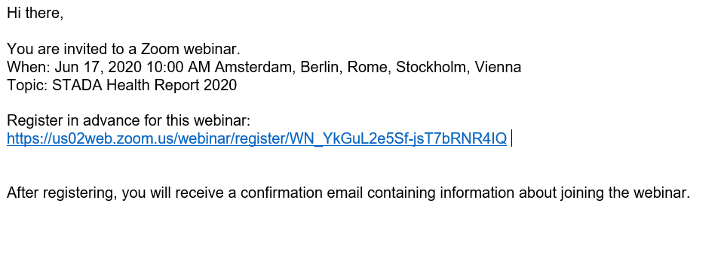

**Step 2:**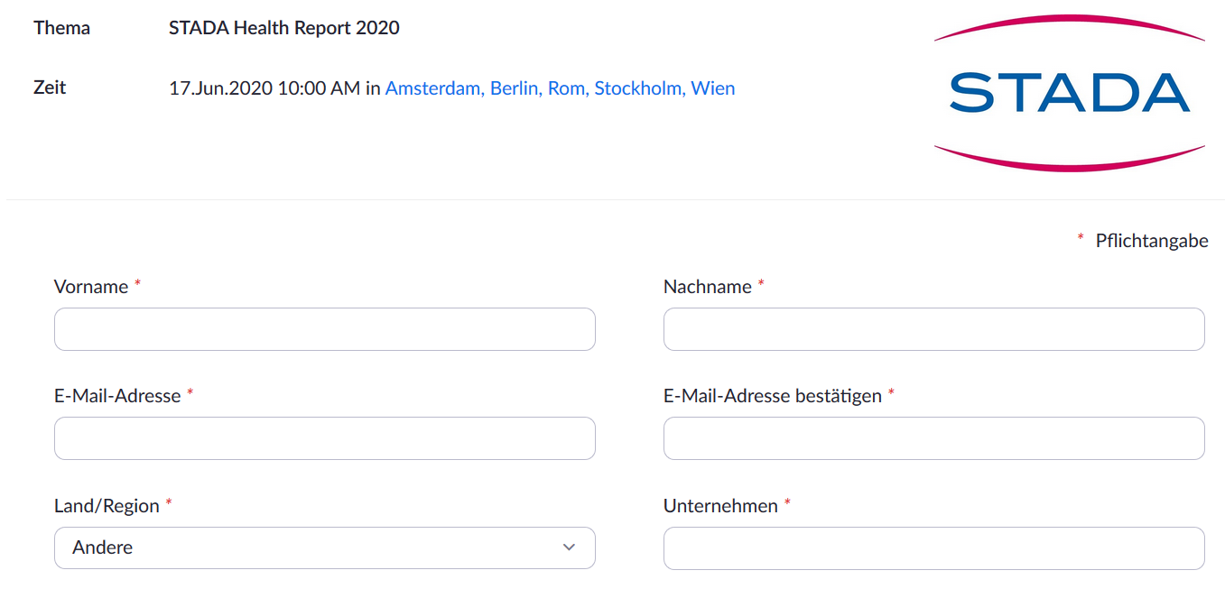 *Please note:   
The language can be adjusted via the settings icon in the bottom right corner of the page:*

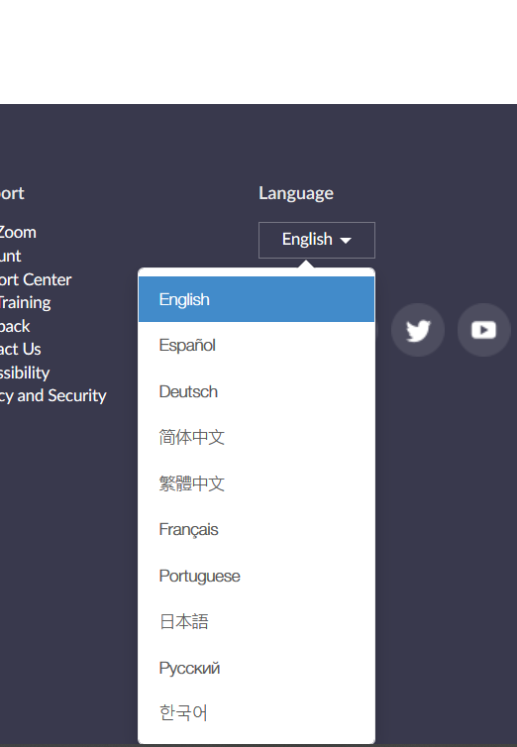

**2. After your registration, you can add the date including the access link to your Outlook calendar or join the webinar directly.**

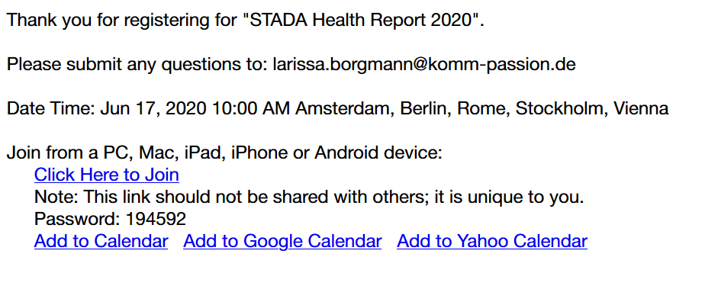

**3. After clicking on the link, the Zoom window opens. Please open the Zoom meeting via the link button at the bottom.**



**What (technical) options do I have during the webinar?**

**Muted during the presentation:** As soon as you join the webinar, you are automatically muted to avoid background noise during the presentation.

**Adjust and test the headphones.** Click on the arrow next to the mute button to open a new window. In this window you can select, adjust and test your headphones.

**How can questions be asked?** You can ask your question at the end of the presentation using the Q&A function. They will be answered by the experts at the end of the presentation.

